**Project Step 15 - Sprint Execution And Review**

**Caleb Pleasant**

Sprint Execution And Review

Correctly planning and executing to a sprint plan is essential to tracking progress for the agile software development process. Product Backlog Items (PBIs) may be sourced from internal as well as external stakeholders but backlog grooming is the product owner's responsibility. The scrum team commits to how many of the highest priority items that they can accomplish during the sprint and, as a team, completes those items one-by-one. At the end of the sprint, the scrum team presents their results to the stakeholders for feedback, project support, and potential requirements change.

This week, execute to your project list, each day moving items from your todo list, to Work-in-progress (WIP) and finally to 'complete'.

**Submit: 1.) Daily screenshots Each day take a screenshot of the Kanban issue board. At the end of the sprint, submit your daily screenshots.**

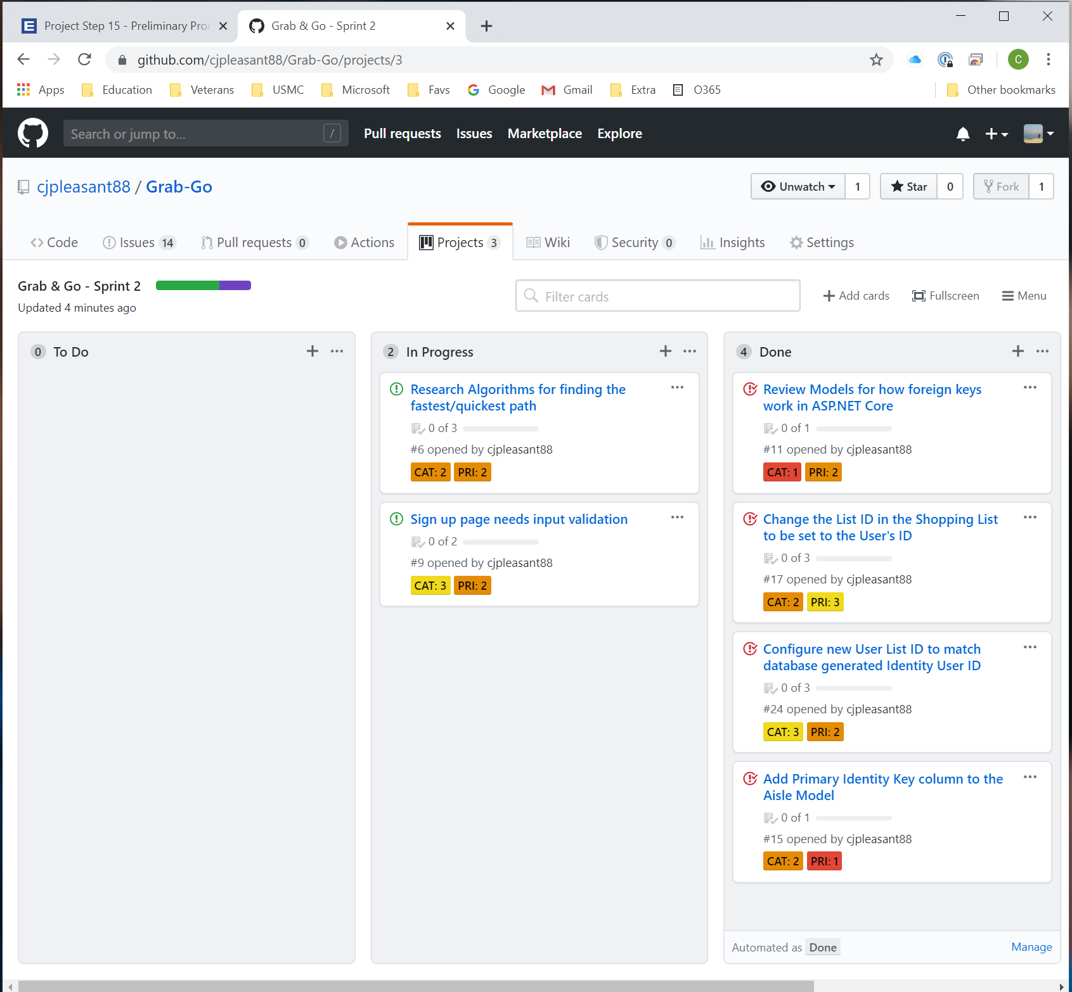

This This is the final screen shot from Sprint 2 that lasted 1 week. I diverted from the sprint this week and focused more on the login pages rather than what I had originally intended. The by product of being the Scrum Master, Product Owner, and the Scrum Team all at once is that it can be easy to divert your attention to things that lead to the intended goal.

**2.) Burndown chart (what is a burndown chart?) There are many sprint tracking tools available. Github is convenient because you can track all elements of your project together, but it doesn't support burndown charts yet. Use any tool to show what a burndown chart of your sprint might look like.**

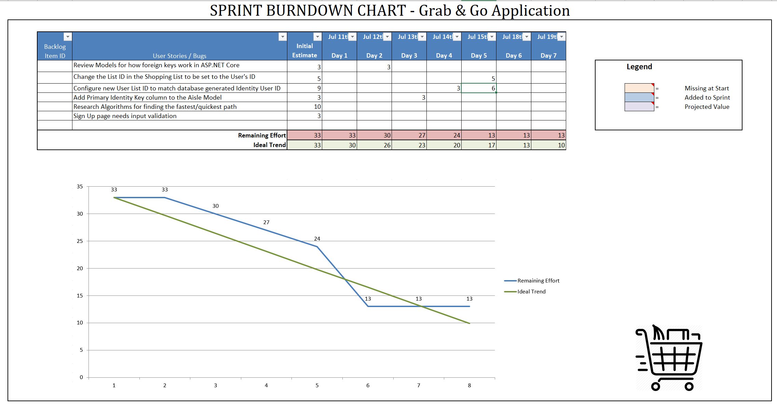

**3.) Sprint Review Answer the following:**

* **Did you complete all items in your sprint plan?**

I did not complete everything I had planned for during the sprint. Lack of planning for unintended side tasks this week left me not giving enough time to this project. I will schedule more time this week and also begin earlier in the week at accomplishing tasks and solving problems the application currently has. Additional tasks were added and accomplished tasks that were not originally planned for this weeks sprint.

* **What is your sprint deliverable? (shippable product(s))**

Adding to last week’s accomplishments, The Application:

* + Upon account creation and edit, the User Shopping List ID now matches the database generated user ID.
  + Using LINQ commands/queries, the users shopping list now populates with currently selected products
  + The User can add items to their persistent shopping list
* **Did you have any task volatility, and what was the cause?**

Yes, Being the entirety of the Scrum Process, it is easy to go on a tangent process/task. This occurred this week and although it allowed additional features to be implemented, it caused originally planned features to not get implemented this week.

* **What would you do differently knowing what you know now?**

Beginning sooner at accomplishing the tasks would have helped greatly. This is common for any task in life, unexpected tasks can occur causing progress to not be what was expected. Taking on side tasks stil lpregressed this weeks project, just not in the areas that were intended. It lightened future areas of work, so this should not affect the ultimate completion date of the project.

**4.) (Next) Sprint Plan Create another 'project' (may be named "sprint 2") and add items from your prioritized backlog issues. Attach a screenshot of the new Kanban board (sprint plan)**

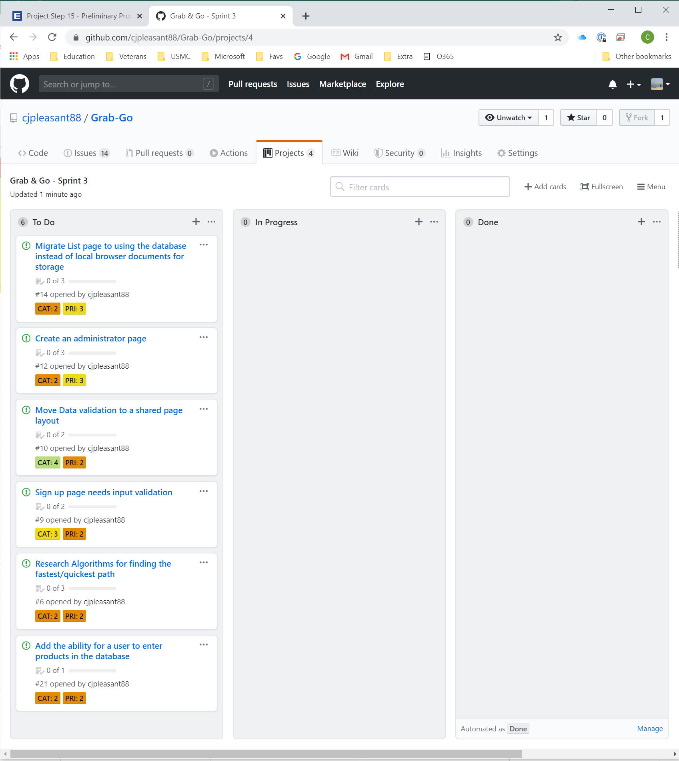

Moved the uncompleted items from sprint 2 to this weeks board. More than normal tasks are added to this weeks board but, I believe they are all achievable. The focus of this week will be to clean up and organize what is currently existing to make future enhancements easier to implement and maintain.